**Exploratory Data Analysis of the Airbnb market in Chania**

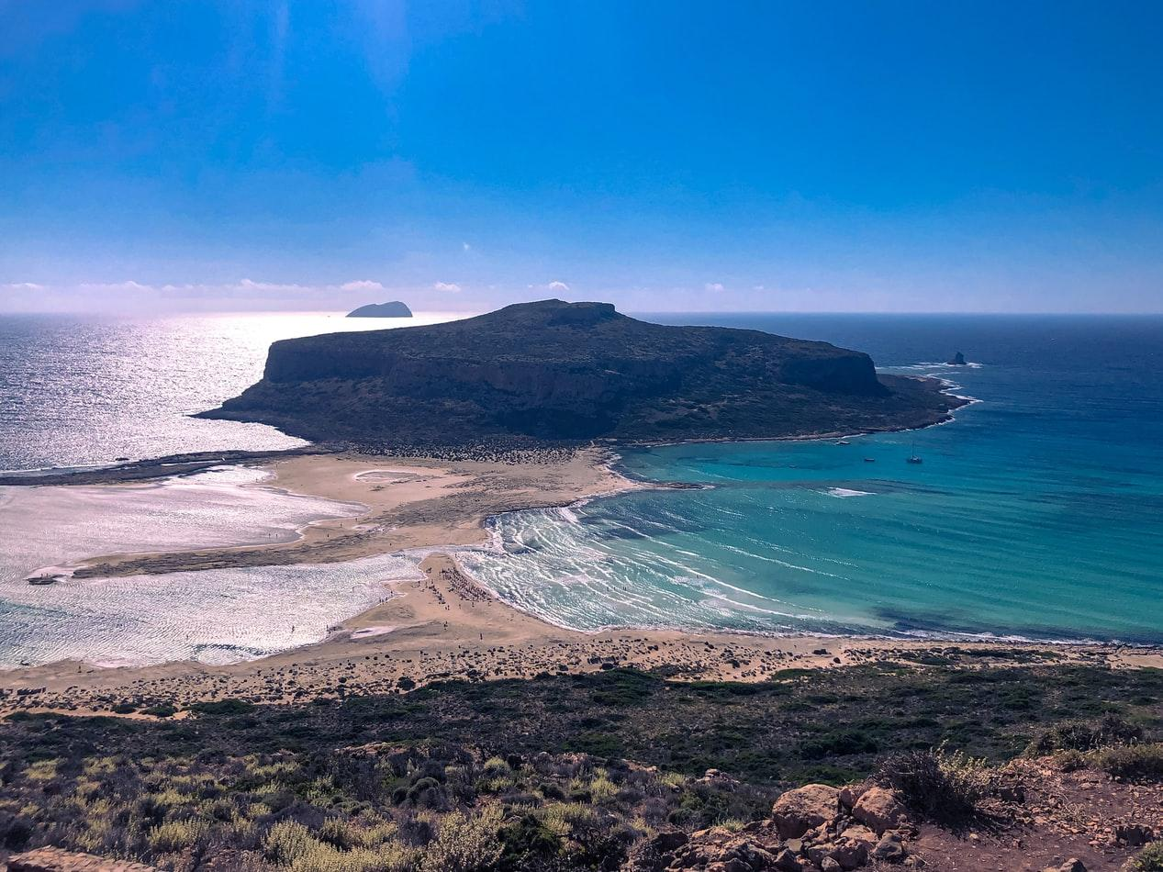

**Introduction:**

Welcome to the Exploratory Data Analysis of the Airbnb market in Chania. This project is aimed at Airbnb hosts to help them understand the local market in Chania.

As an Airbnb host in Chania, Crete, I was always astonished by the increase in Airbnb rentals on my island. Below is my data analysis explanation to help understand how that market has evolved and what matters the most now.

Let’s take a look at the following questions:

* What are the different types of properties in Chania? Do they vary by neighbourhood?
* Which cities are rated highly by guests?
* What is the distribution of prices by neighbourhood?
* What are the characteristics of the listing which sell at the highest price?
* Factors that are correlated the most with Airbnb superhosts

**Understanding the dominance of Airbnb in Chania, Crete**

We began by looking at property type distribution and how that varies from city to city. Most of the Airbnb rentals in Chania are entire apartments, villas or houses (75%) primarily located in the city in the centre of the region. Check out the graph below.

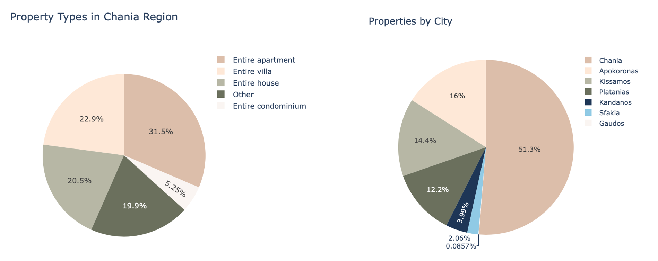

**Popularity of Airbnb**

Since 2012 Airbnb has increased in popularity as an alternative to hotels. It is now one of the world’s most popular platforms for short term rentals. Demand for Airbnb increased dramatically in 2016. In 2019 Airbnb peaked with more than 30k reviews.

Location is a major factor. Average Airbnb ratings for the Chania region are 4.8, with Gaudos and Kandanos doing even better at 5 and 4.9 respectively.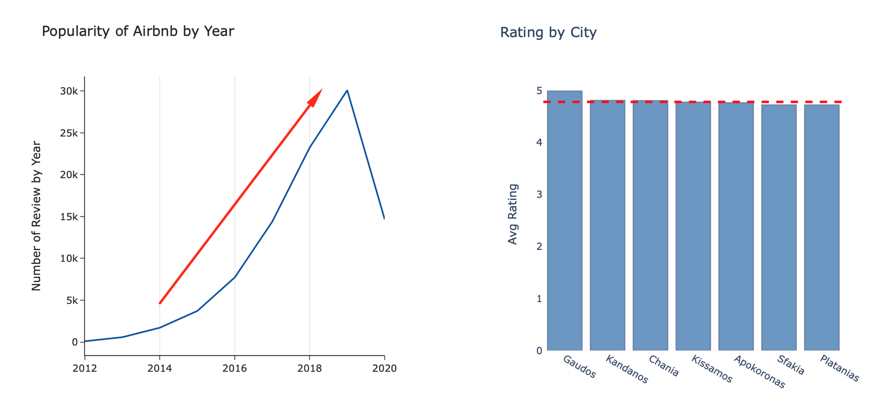

**Which city can charge the most?**

The average price per person is in the 25-35 euros per night range across all cities. Chania and Platanias are the two cities with most rentals outside of this range. This makes sense. Both are very popular with tourists and are close to famous beaches and landmarks. We looked at the average price per person, by property type, bearing in mind that villas and houses are more expensive but can accommodate more people.

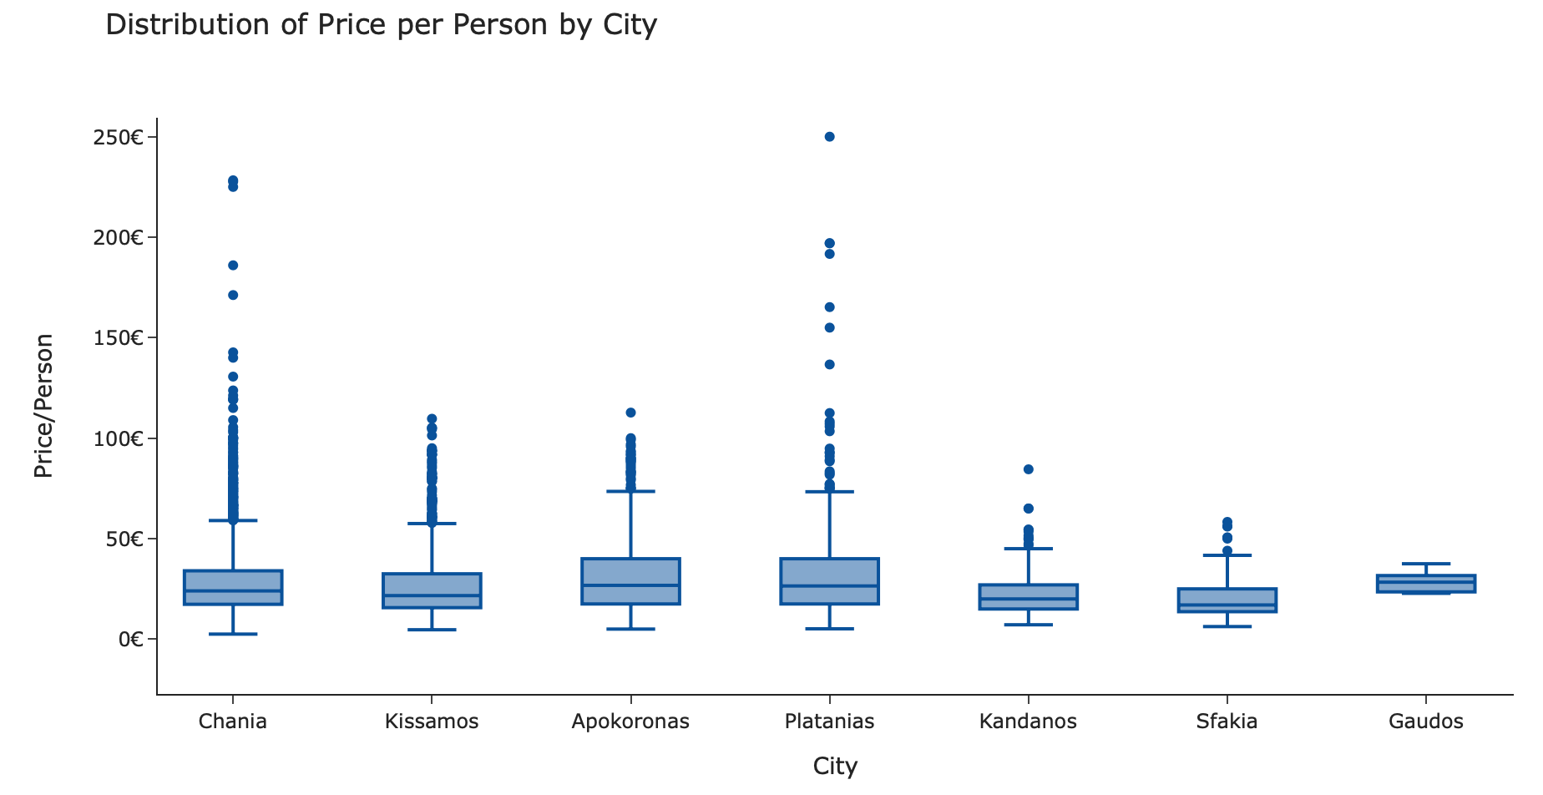

**What are the characteristics of the listings which sell at the highest price?**

After identifying the price distribution of properties, we looked at the common attributes of the top rental properties. We fitted a simple linear model after removing multicollinear features that have a VIF score above 6.

As expected, the most expensive properties per person were villas and rooms in boutique hotels. These had excellent locations and a plethora of services from “Superhosts”.

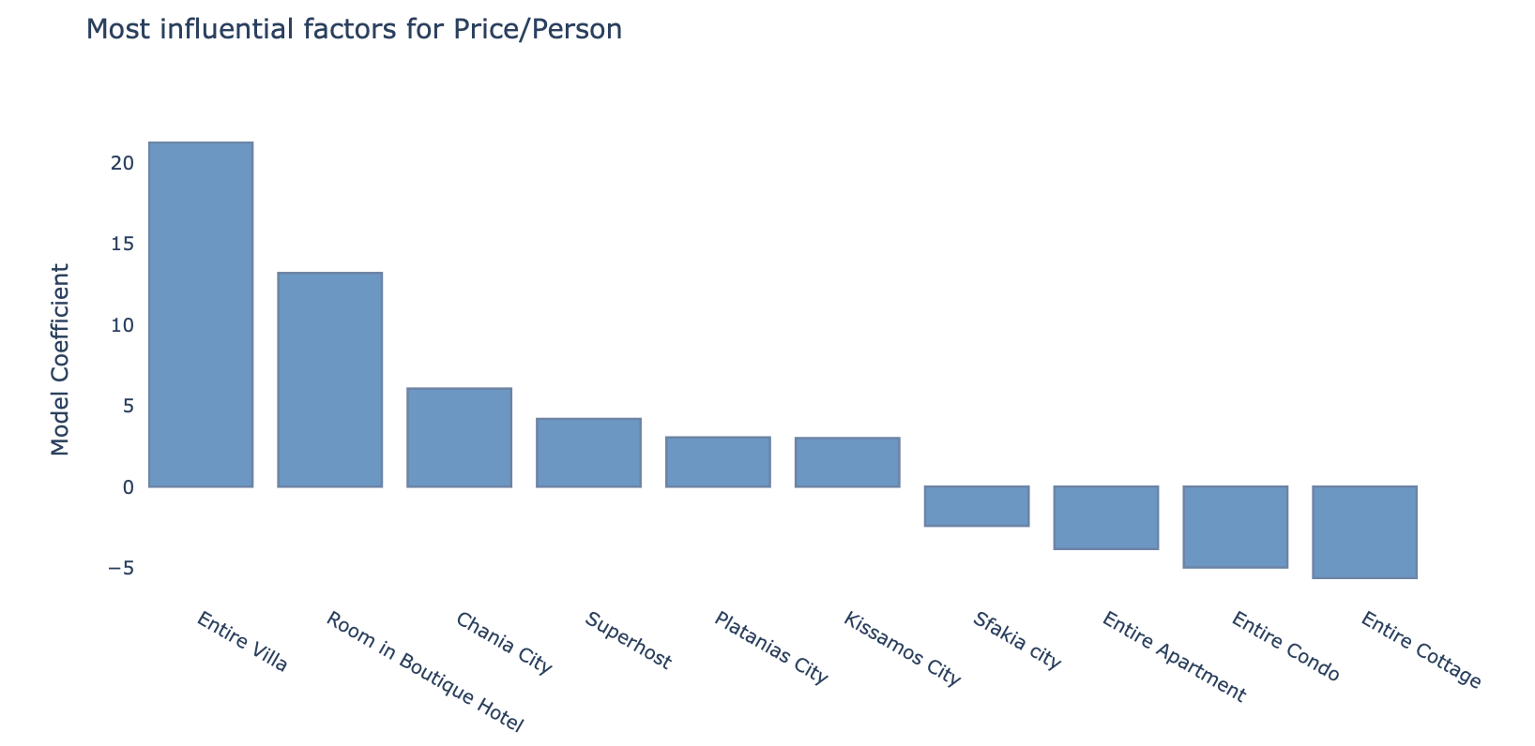

**Attributes correlated to Superhosts**

Superhosts usually charge a higher rate per person (check the graph above). We looked at the most correlated factors associated with Superhosts. Hosts with the most reviews, fastest response rates, top overall ratings and highest review scores are most likely to achieve “Superhost” status.

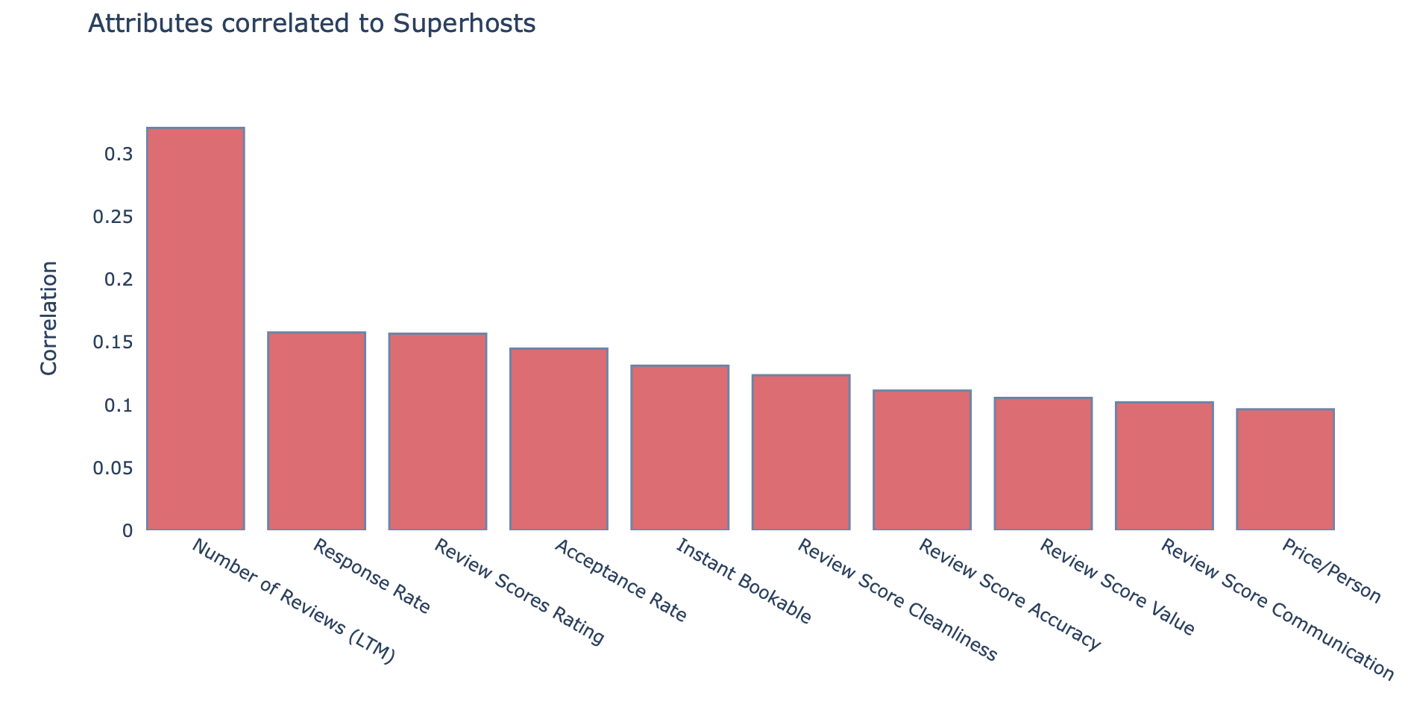

**Summary:**

* Demand for Airbnb has increased dramatically since 2012. 2019 has been the best year so far.
* Most of the properties in the Chania region are apartments and villas located in Chania city.
* The average price per person ranges from 25-35 euros per night across all cities. Chania and Platanias have the highest range of prices above this.
* Superhosts that rent Villas or Rooms in Boutique hotels in Chania, Platanias or Kandanos cities tend to charge the most.
* To become a “Superhost'' it helps to have lots of top reviews, a fast response rating, and a high acceptance level.

Data sourced from:I nsideAirbnb website; http://insideairbnb.com/get-the-data.html which hosts publicly available data from the Airbnb site.

This project is available on Github: <https://github.com/vProto/DS_Projects>